**Microsoft Azure Assignment**

**Link:** [https://karim-mustafa-app](https://karim-mustafa-app.azurewebsites.net/)

Name: Karim Mahmoud Kamal

Section: 2

B.N: 12

Name: Mustafa Mahmoud Hamada

Section:2

B.N: 25

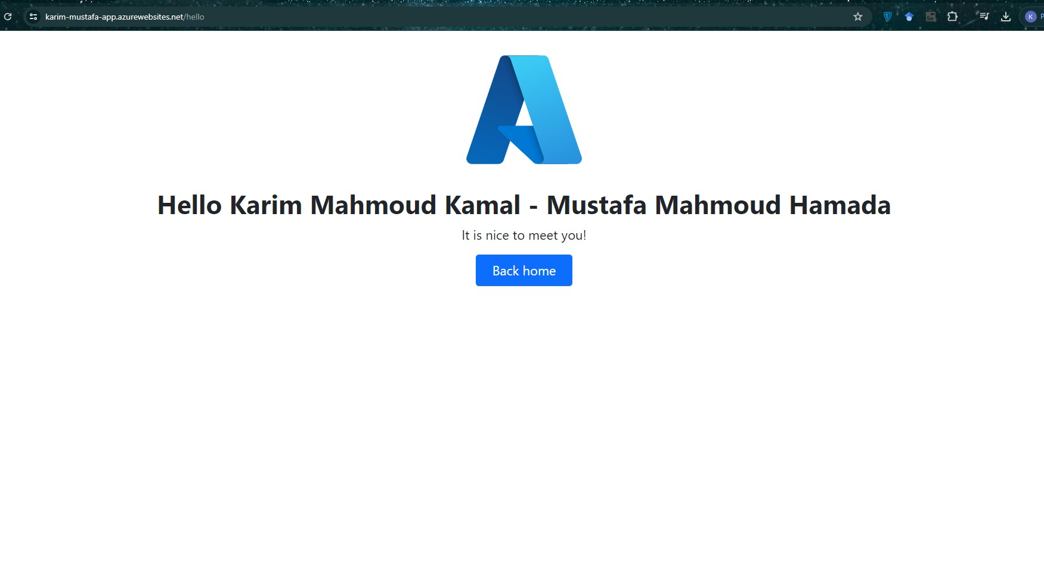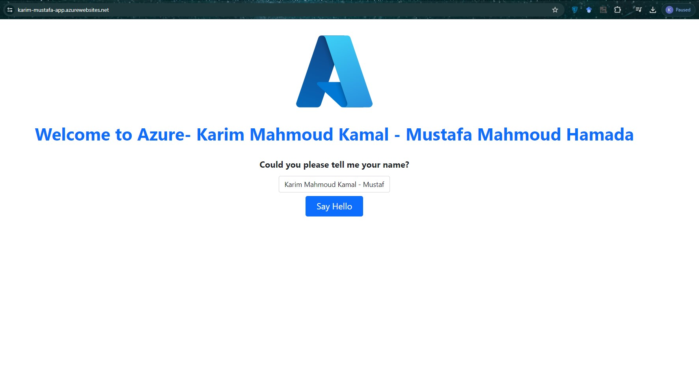**Screenshots**:

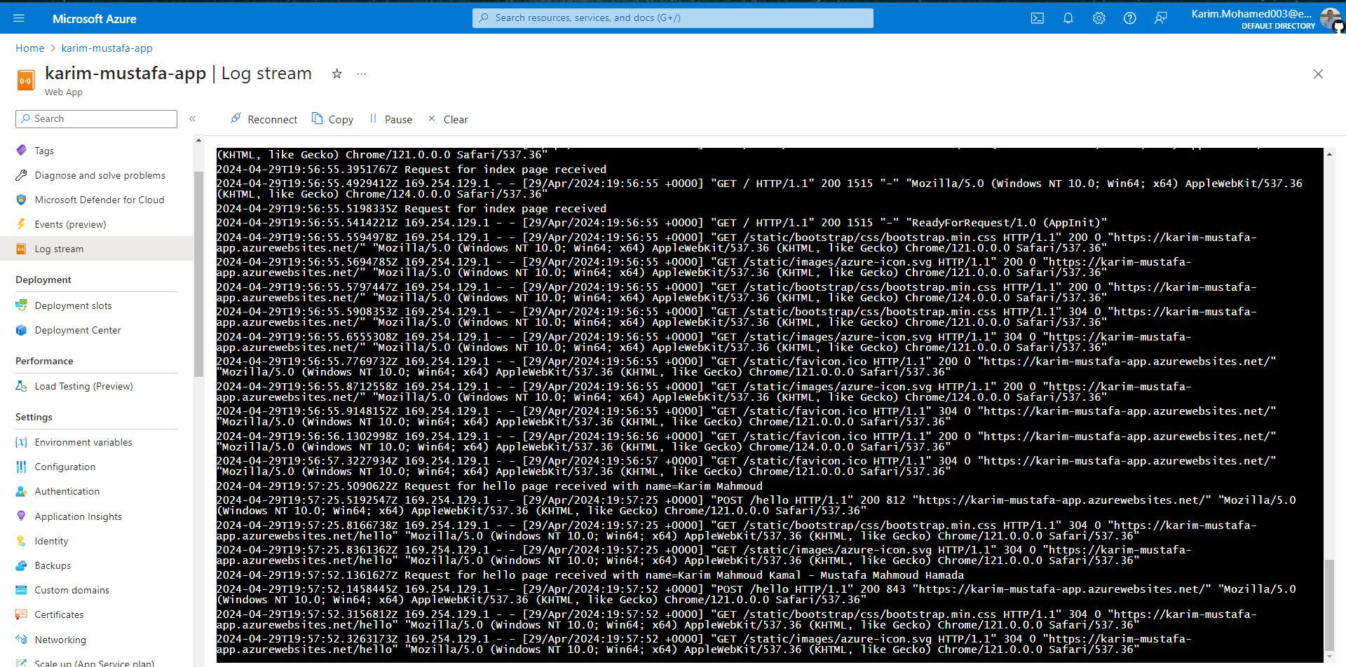**Logs:**